USA and Canada win many awards at the 2013 International Linguistics Olympiad
Eight American and four Canadian high school students brought a number of awards at 2013 International Linguistics Olympiad (IOL) held between July 22 and 26 in Manchester, UK.

FOR IMMEDIATE RELEASE

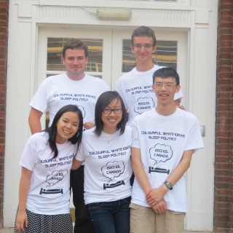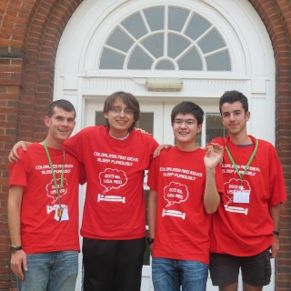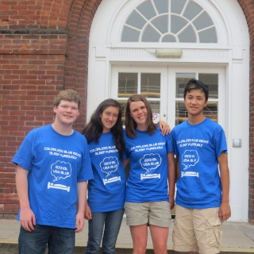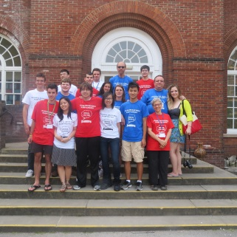

(Press Release) – July 26, 2013 International Linguistics Olympiad (IOL)
Hosted by Manchester Grammar School and the University of Manchester
July 22 – 26, 2013, Manchester, UK
Team Canada (white T-shirts; left to right): Jordan Ho (Toronto, ON), Janis Chang (Toronto, ON), Stella Lau (Toronto, ON), and Daniel Lovsted (Toronto, ON)
Team USA Red (red T-shirts; left to right):, Tom McCoy (Pittsburgh, PA), Max Schindler (St. Louis, MO), Alexander Wade (Reno, NV), and Aaron Klein (Brookline, MA)
Team USA Blue (blue T-shirts: left to right): Erik Andersen (Sunnyvale, CA), Simone Stoyen (Herndon, VA), Rebecca Burks (Los Altos, CA), and Jeffrey Ling (Palo Alto, CA)
Coaches: Pat Littell (Canada) and Dragomir Radev (USA), NACLO Chair Lori Levin, and Sponsorship Chair James Pustejovsky.
On July 19, eight Americans and four Canadians traveled to Manchester, UK, to join over 30 teams from around the world at the 2013 International Linguistics Olympiad (IOL). The North Americans, who all trained together, performed extremely well.

The IOL, one of twelve international science olympiads, consists of two events. The first is the individual contest, a six-hour test, which this year had problems about the languages Yidini, Tundra Yukaghir, Pirahã, and Muna, as well as a problem on functional magnetic resonance imaging (fMRI). The second event is the team contest, which this year involved an ancient variant of Georgian, the language of the Republic of Georgia in the Caucasus region of Eurasia. To solve these problems, contestants must apply knowledge about the way languages work as well as logic and reasoning skills to decipher unfamiliar languages and writing systems.
One of the two USA Teams (USA Red) won both team competitions. In the team problem competition, the US team was followed by Russia, Bulgaria, and Romania.

In the individual contest, the absolute winner among all 137 contestants, with 87 points out of 100, was Alex Wade (USA Red), who received one of seven gold medals; the other six gold medals went to contestants from Russia, the Czech Republic, Brazil, Poland, Bulgaria, and Latvia. Jeffrey Ling and Aaron Klein won silver medals for the US teams. Max Schindler and Tom McCoy won bronze for the USA and Daniel Lovsted won a bronze for Canada.
The three teams were selected through the North American Computational Linguistics Olympiad (NACLO). This annual competition has two rounds, which are held at universities and high schools throughout the USA and Canada. This year over 1,700 students took the open round, a three-hour test. Approximately the top 10% of the students from the open round were invited to the next round, a more difficult, five-hour test. The joint American-Canadian practices, which were conducted via Skype by the USA coaches Dragomir Radev, a professor at the University of Michigan, and Lori Levin, a professor at Carnegie Mellon University, and the Canadian coach Pat Littell, a doctoral student at the University of British Columbia. Professor James Pustejovsky of Brandeis University chaired the fundraising committee for the team. The teams’ sponsors include the Feldberg Foundation, Brandeis University, the North American Chapter of the Association for Computational Linguistics (NAACL), the Linguistics Society of America (LSA), Carnegie Mellon University, the University of Michigan, as well as individual donors and parents.
In addition to competing, the students at the IOL also explored Manchester and made friends from all over the world. Twenty-six countries were represented this year. Next year’s IOL will be held in Beijing, China.
More info:
IOL 2013 http://www.uklo.org/iol-2013
NACLO http://www.naclo.cs.cmu.edu
IOL http://www.ioling.org
Contact:
Dragomir Radev radev@umich.edu
Lori Levin lsl@cs.cmu.edu
Pat Littell puchitao@gmail.com

